
INTERNATIONAL CYBERSECURITY AND DIGITAL FORENSICS ACADEMY

ASSIGNMENT

Assignment Title: Linux Command Line For Digital Forensics
Student Name: Ahmad Zubairu Garba
Student ID: 2025/FWSD/11463
Course Title: Basic Computer Skills for Digital Forensics
Course Code: SBT-DF201
Instructor: Aminu Idris

August 16th , 2026
1. INTRODUCTION
Digital forensics requires direct, non-destructive interaction with file systems, metadata, and logs to ensure evidence integrity is maintained. This lab establishes core command-line techniques such as workspace initialization, directory traversal, text pattern matching, safe networking diagnostics, script automation, and archiving to equip analysts for live response and artifact recovery.
2. Lab Environment & Setup
- Operating System: Kali Linux Rolling (Version 2026.3)
- Kernel & Architecture: Linux 7.0.12+kali-amd64 on x86_64
- User Context: garba (UID 1000) with standard sudo privileges
- Core Utilities Used: tree, nmap, wget, zip, unzip, tar, net-tools, terminator, nano, grep, stat, ss, ip, find
- Package Staging: Missing utilities were resolved via repository synchronization and apt install.

3. Tasks Performed & Command Execution
Prepare Your Evidence Workspace
Create a structured workspace to hold all commands, outputs, screenshots, and final evidence artifacts.
Commands Executed:
cd ~
mkdir -p CIP-B101_Lab2A_Garba_Ahmed/{notes,evidence,scripts,outputs,screenshots,archive}
cd CIP-B101_Lab2A_Garba_Ahmed
pwd
ls -la
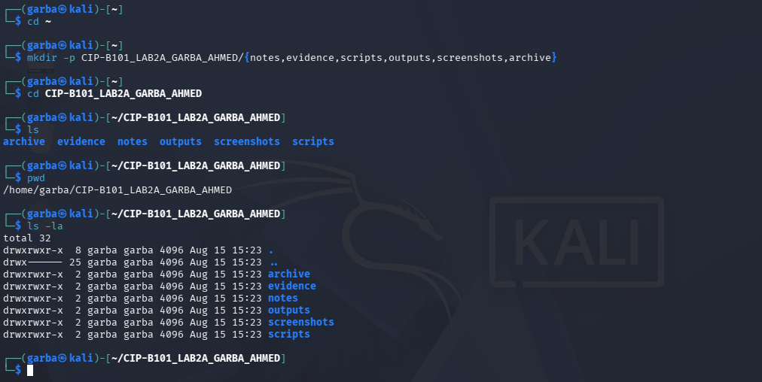
Task 2: Inspect Linux Filesystem and OS Information
Observe the Linux filesystem hierarchy, operating system release details, and basic execution privileges.
Commands Executed:
clear
pwd
ls /
ls -la /
cat /etc/os-release
uname -a
whoami
id
- Evidence Screenshots:

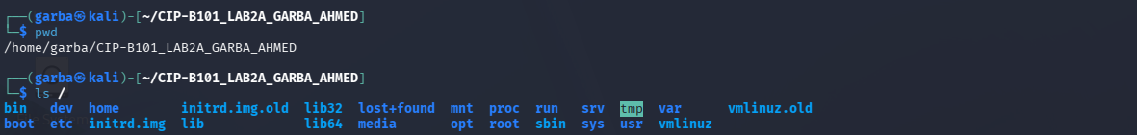
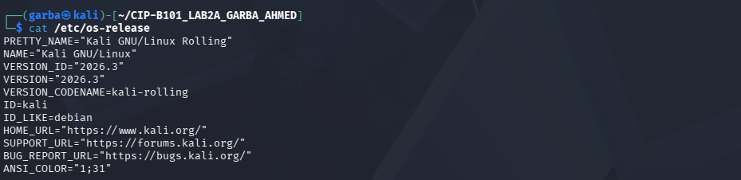
Task 3: Understand Inodes and Disk Information
Create a test evidence file and inspect its inode, system metadata, and storage constraints.
Commands Executed:
echo "This is Lab 2A evidence file created by Garba Ahmed" > evidence/lab2a_evidence.txt
ls -li evidence/lab2a_evidence.txt
stat evidence/lab2a_evidence.txt
df -h
df -i
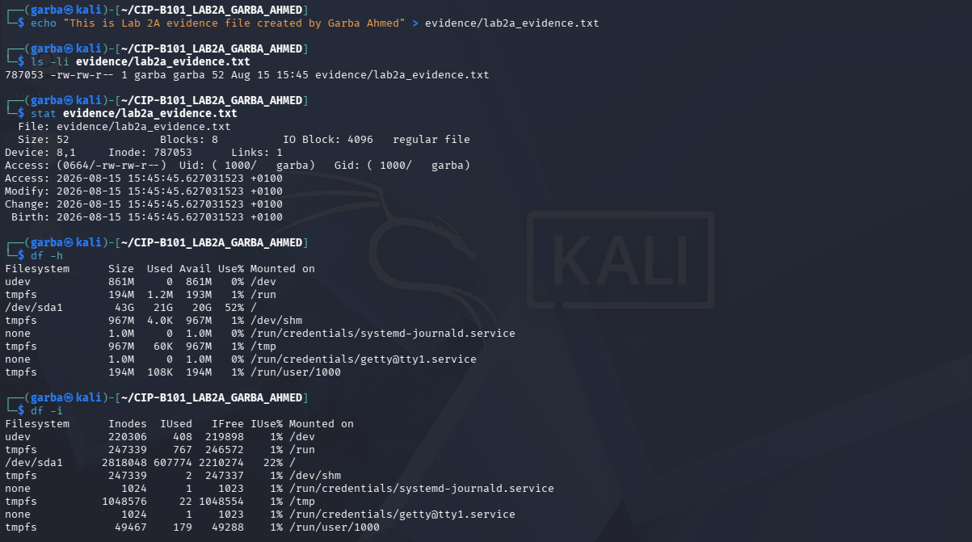
Task 4: Absolute and Relative Paths
Demonstrate fluency with absolute and relative paths by navigating directories via the command line.
Commands Executed:
cd ~/CIP-B101_Lab2A_Garba_Ahmed/evidence
pwd
cd ..
pwd
cd ./notes
pwd
cd ../evidence
pwd
readlink -f lab2a_evidence.txt
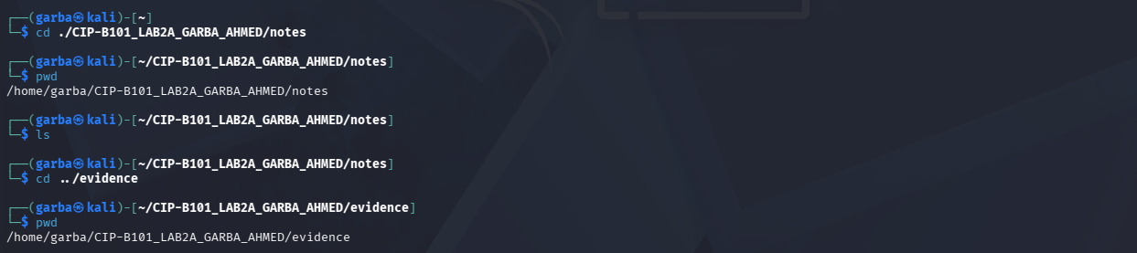

Task 5: Create, View, Copy, Rename and Remove Files
Execute basic file management workflows standard for organizing working copies and forensic extractions.
Commands Executed:
cd ~/CIP-B101_Lab2A_Garba_Ahmed
echo "Case Note 1: Initial Linux command line practice" > notes/case_note1.txt
echo "Case Note 2: Evidence handling requires careful documentation" > notes/case_note2.txt
cat notes/case_note1.txt
cat notes/case_note2.txt
cp notes/case_note1.txt evidence/case_note1_copy.txt
cp -r notes evidence/notes_backup
mv evidence/case_note1_copy.txt evidence/case_note1_renamed.txt
ls -la evidence
echo "temporary data" > evidence/temp_delete_me.txt
ls -la evidence/temp_delete_me.txt
rm evidence/temp_delete_me.txt
ls -la evidence
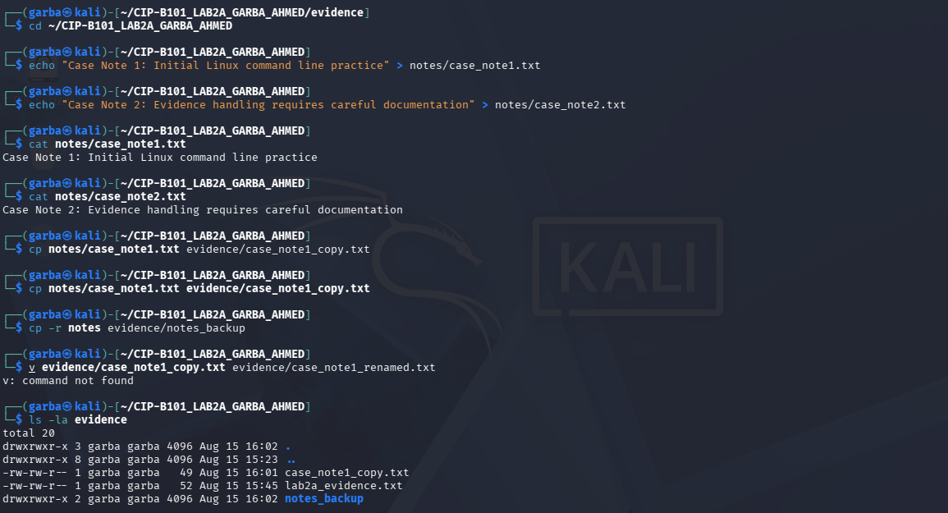
Task 6: Search Evidence Content with grep
Parse text-based logs using structured heredocs and extract investigative indicators using regular expressions.
Commands Executed:
cat > evidence/activity_log.txt <<'EOF'
2026-06-19 09:10 user=aminu action=login status=success ip=192.168.56.10
2026-06-19 09:25 user=guest action=file_copy status=success file=report.docx
2026-06-19 10:05 user=admin action=login status=failed ip=192.168.56.15
2026-06-19 10:20 user=aminu action=delete status=success file=temp.txt
2026-06-19 10:40 user=admin action=password_change status=success
EOF
cat evidence/activity_log.txt
grep "login" evidence/activity_log.txt
grep -n "failed" evidence/activity_log.txt
grep -Ei "delete|password" evidence/activity_log.txt
grep -Ei "192\.168\.56\.[0-9]+" evidence/activity_log.txt
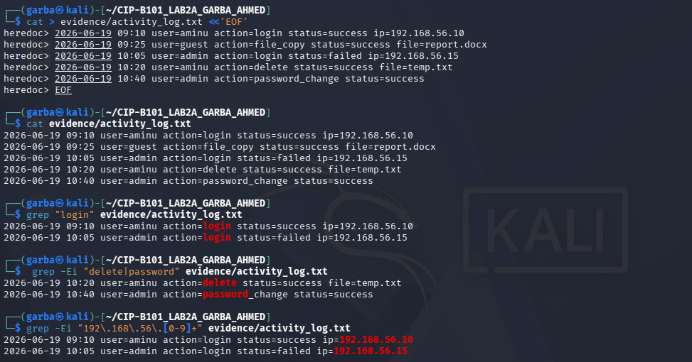
Task 7: Search File Names and Display Directory Tree
Map out workspace layouts using tree and locate files dynamically using name and pattern searches with find.
Commands Executed:
cd ~/CIP-B101_Lab2A_Garba_Ahmed
tree
find . -type f -name "*.txt"
find . -type f -iname "*log*"
find . -type d -name "evidence"
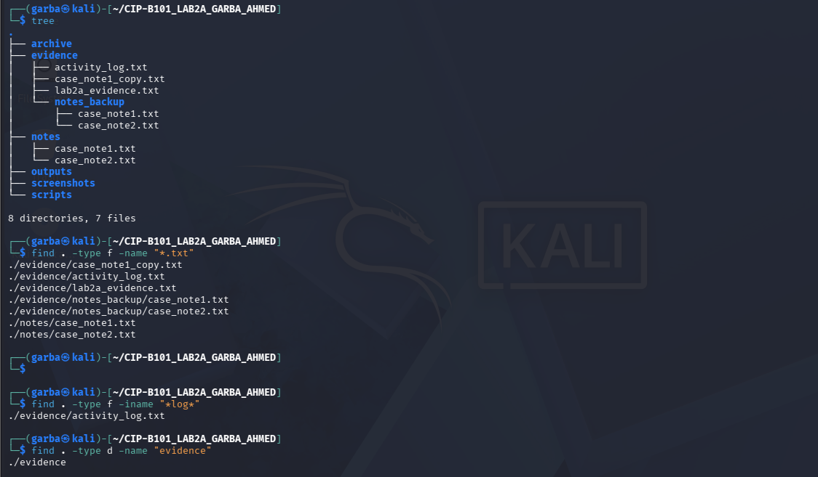
Task 8: Check Network Information Safely
Inspect local network configurations, routing tables, loopback availability, open ports, and local socket listeners safely.
Commands Executed:
ip addr
ip route
ping -c 4 127.0.0.1
ping -c 4 localhost
ss -lnt
nmap localhost -p 22,80,443 2>/dev/null || echo "nmap unavailable or no services detected"
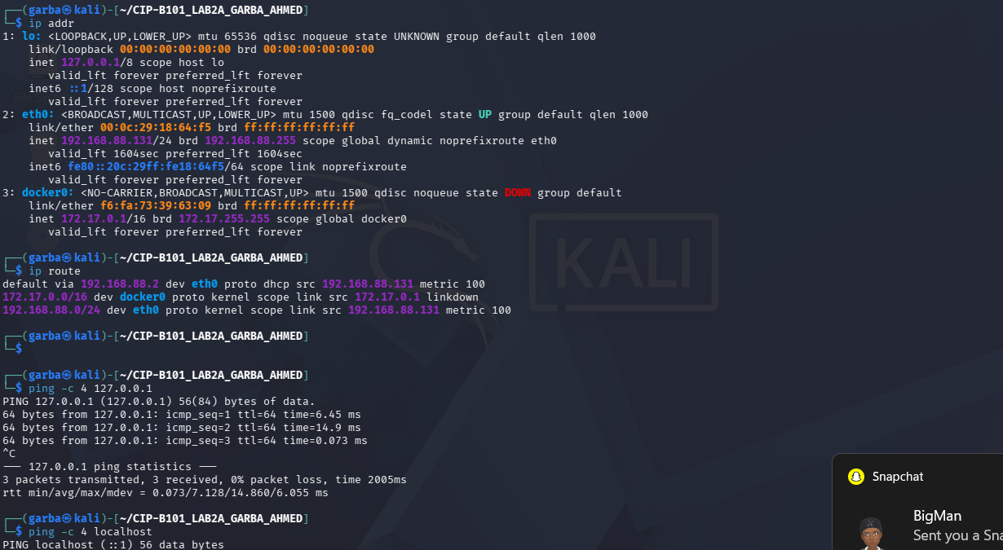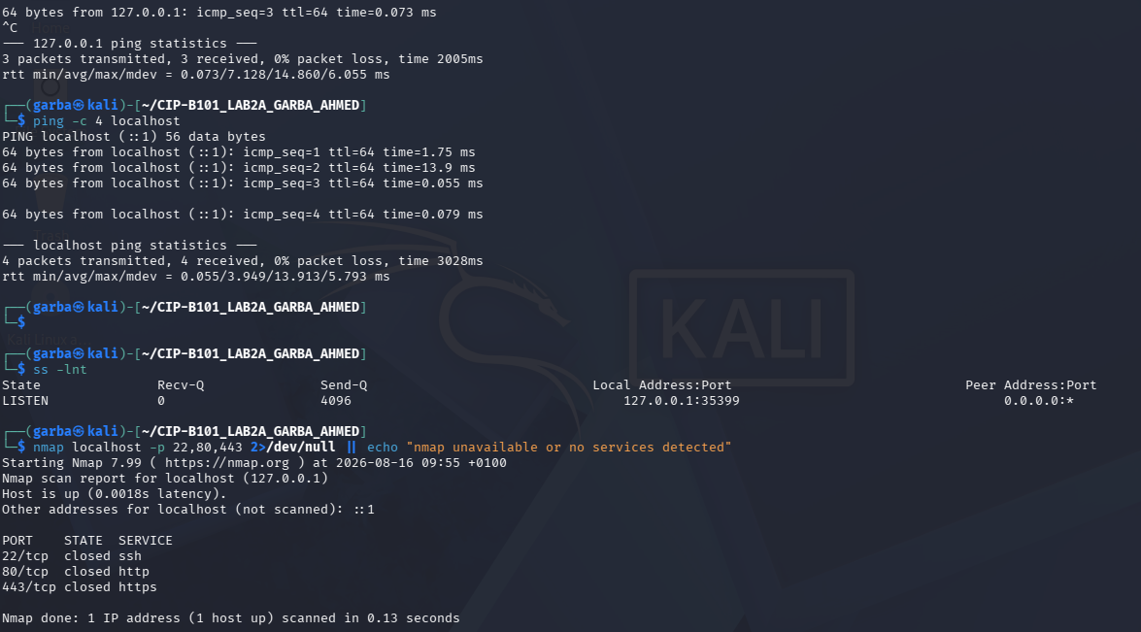
Task 9: Create and Execute a Simple Forensic Script
Build an automated shell script to record system states, disk metrics, and folder trees into an output report.
Script Configuration (scripts/lab2a_sys_summary.sh):

#!/bin/sh
# CIP-B101 Lab 2A system summary script
# Student: Garba Ahmed
OUT="$HOME/CIP-B101_Lab2A_Garba_Ahmed/outputs/system_summary.txt"
{
echo "===== CIP-B101 Lab 2A System Summary ====="
echo "Date/Time: $(date)"
echo "User: $(whoami)"
echo "Hostname: $(hostname)"
echo "Kernel: $(uname -a)"
echo "Current Folder: $(pwd)"
echo "===== Disk Space ====="
df -h
echo "===== Inode Usage ====="
df -i
echo "===== Evidence Workspace Tree ====="
tree "$HOME/CIP-B101_Lab2A_Garba_Ahmed"
} > "$OUT"
echo "Summary saved to $OUT"
- Commands Executed:

Bash
cd ~/CIP-B101_Lab2A_Garba_Ahmed/scripts
chmod +x lab2a_sys_summary.sh
ls -l lab2a_sys_summary.sh
./lab2a_sys_summary.sh
cat ../outputs/system_summary.txt | head -n 30
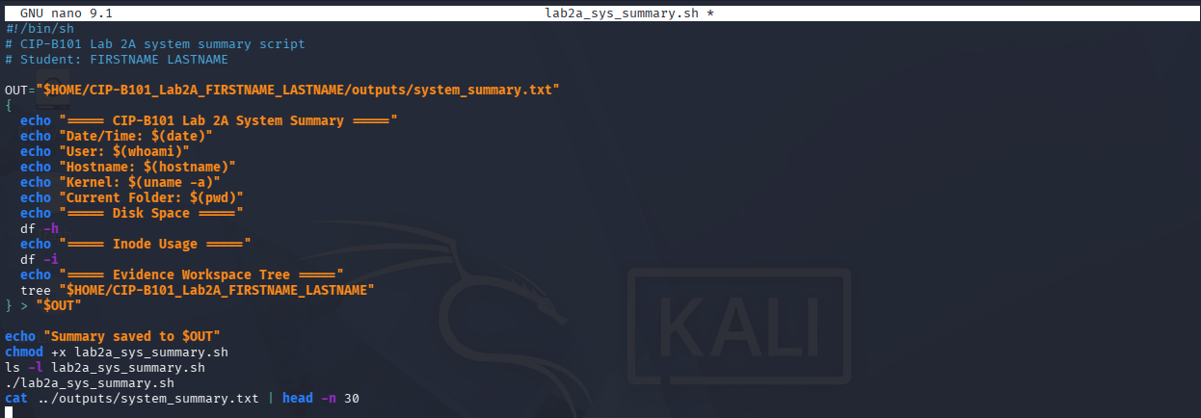
Task 10: Make the Script Callable from Another Folder Using PATH
Temporarily modify the PATH environment variable to execute custom scripts globally from any directory.
Commands Executed:
export PATH=$HOME/CIP-B101_Lab2A_Garba_Ahmed/scripts:$PATH
cd /tmp
lab2a_sys_summary.sh
cat ~/CIP-B101_Lab2A_Garba_Ahmed/outputs/system_summary.txt | head -n 15
Task 11: Compress the Evidence Workspace
Bundle and compress the finalized investigative workspace using standard archiving tools for transport.
Commands Executed:
cd ~
zip -r CIP-B101_Lab2A_Garba_Ahmed.zip CIP-B101_Lab2A_Garba_Ahmed
tar -czvf CIP-B101_Lab2A_Garba_Ahmed.tar.gz CIP-B101_Lab2A_Garba_Ahmed
ls -lh CIP-B101_Lab2A_Garba_Ahmed.zip CIP-B101_Lab2A_Garba_Ahmed.tar.gz
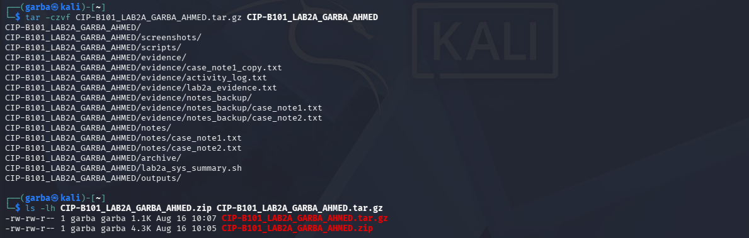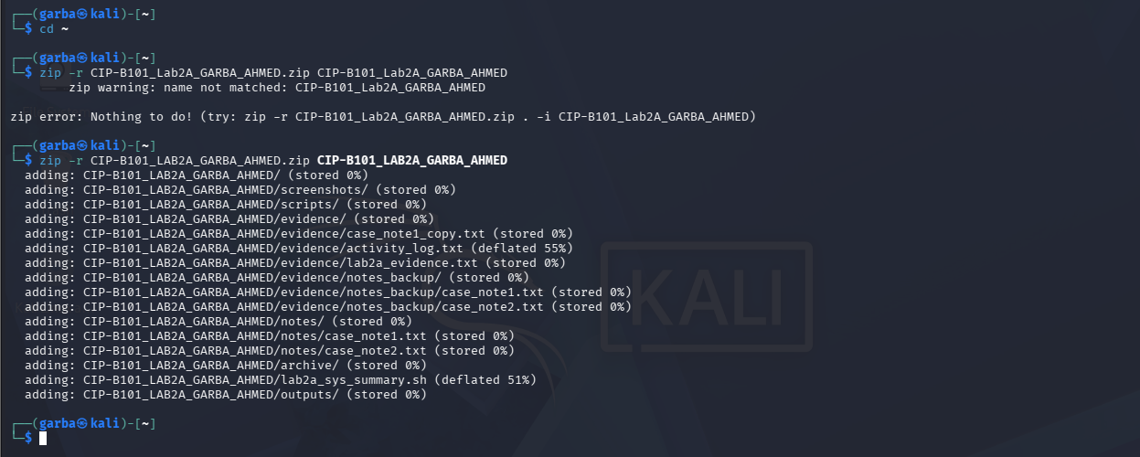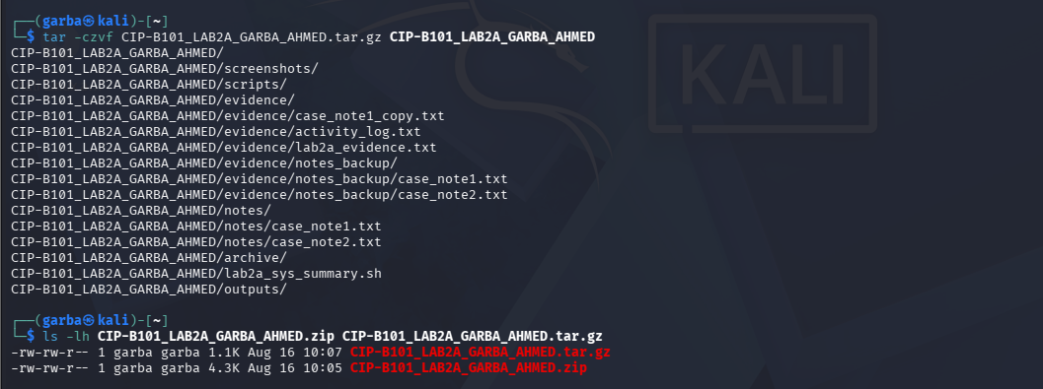
4. Forensic Interpretation & Technical Insights
Inodes: An inode is a kernel data structure that stores file metadata such as permissions, timestamps, ownership, and disk block pointers while explicitly excluding the file name. In digital forensics, inodes are critical because they persist independently of the file name, enabling analysts to track, analyze, and recover files even after they have been renamed or unlinked.

- The PATH Variable: The PATH environment variable defines an ordered list of directory paths that the shell scans to locate executable binaries when a command is invoked. Configuring custom script directories allows analysts to execute specialized tools globally without specifying absolute paths.
- Grep Pattern Filtering: Regular expression and pattern matching via grep allow investigators to instantly isolate indicators of compromise (IoCs), error codes, or specific transactional log entries out of large datasets.
- Localhost Testing: Restricting network diagnostics and socket analysis to loopback addresses (127.0.0.1 / ::1) ensures safety, compliance, and strict containment within the local machine stack during testing.
5. Report Questions & Answers
What is a Linux inode and why is it important?
An inode is a kernel data structure holding file metadata (permissions, timestamps, ownership, and disk block pointers) minus the file name. It is crucial in forensics because it persists independently of the file name, allowing analysts to track and recover files even after they have been renamed or deleted.
What is the difference between an absolute path and a relative path?
An absolute path specifies a location starting directly from the root directory (/), providing a fixed, unvarying reference regardless of the current working directory. A relative path specifies a location relative to the user's current active directory.
Why does Linux say “everything is a file”? Give two examples from /dev, /proc, /sys, or /etc.
Linux abstracts hardware devices, processes, system information, and configuration settings through the Virtual File System (VFS) as unified file streams.
  - Example 1: /dev/sda1 represents a physical block storage device.

  - Example 2: /etc/os-release contains operating system release configuration text.

What is the purpose of the PATH variable?
The PATH variable establishes an ordered list of directories that the command shell scans to locate executable binary files whenever a command is invoked, sparing the user from typing out full file paths.
Which grep command did you use to identify failed login evidence?
grep -n "failed" evidence/activity_log.txt
Why should a forensic trainee avoid scanning unauthorized external systems?
Scanning external networks or unauthorized systems without explicit authorization violates legal boundaries, breaches chain-of-custody protocols, and can trigger network disruptions or false alarms.
What is the difference between zip and tar.gz in this lab context?
zip packages files into a universally compatible compressed archive format. tar.gz creates a tape archive (tar) compressed with gzip (.gz), which natively preserves detailed Linux file permissions, ownership properties, and user attribute structures.
6. Challenges & Resolution
- Challenge: Certain automation utilities and network scanning packages were missing from the baseline installation.
- Resolution: Updated package repositories using sudo apt update and successfully staged the required tools using sudo apt install -y tree nmap wget zip unzip tar net-tools terminator nano.
7. Conclusion
This practical laboratory successfully demonstrated foundational command-line operations essential for digital forensics. Proficiency was gained in filesystem navigation, metadata evaluation via inodes, pattern-based searching, safe network diagnostics, script automation, and evidence archiving, building a strong base for upcoming digital forensics investigations.

